**Learning Objectives:**

* State the concepts of dynamic analysis of slider crank mechanisms
* Understand the significance of parameter and select the variable accordingly.
* Calculate the velocity, acceleration and force acting on each link.
* Examine the calculated values with the simulation results
* Evaluate how change in length, angle and driving force results in change of acceleration, velocity and work done by the mechanism

**THEORY**

The slider crank mechanism is one of the most basic forms of closed loop mechanisms., it is modification of the basic four bar chain. It has a single degree of freedom and is often used to convert rotary motion into linear motion by varying link lengths. It is, usually, found in reciprocating steam engine mechanism. From an application perspective it is very important to understand the dynamics of such a system. The kinematics of the system is largely governed by the link length and so is the dynamics of the system. [1]

Through the process of the simulation, one would understand how to calculate the forces on each link for a constant angular velocity as input. The dynamic analysis of the slider crank mechanism is covered after understanding the kinematic analysis since the acceleration of the links are required to calculate the forces on the link.[1]

**Equations/formulas:**

**Dynamic force Analysis of a 4 – link mechanism.**

The slider crank mechanism is shown in [Fig.1(a)](https://learning.oreilly.com/library/view/Theory+of+Machines/9789332528567/xhtml/chapter011.xhtml#ch11fig22). Let P be the force on the piston due to gas pressure and ω2 the angular velocity of link 2, be known. Points G2, G3, and G4 are the centers of mass of links 2, 3, and 4. We are interested to find the torque T2, which the crank 2 exerts on the crankshaft and the shaking force.

The velocity and acceleration polygons are constructed first, as shown in [Fig.1(b)](https://learning.oreilly.com/library/view/Theory+of+Machines/9789332528567/xhtml/chapter011.xhtml#ch11fig22) and (c), respectively. Link 3 and 4 combined as a free body are shown in Fig 1(d). The unknowns are the magnitudes of F23 and F14. By taking moments about B, we have

F14a + f3b + f4d–Pd = 0

or

ch11-ueq17

Force F23 can then be found by a summation of forces on bodies 3 and 4 together as a free body. The force polygon is shown in [Fig.1](https://learning.oreilly.com/library/view/Theory+of+Machines/9789332528567/xhtml/chapter011.xhtml#ch11fig22)

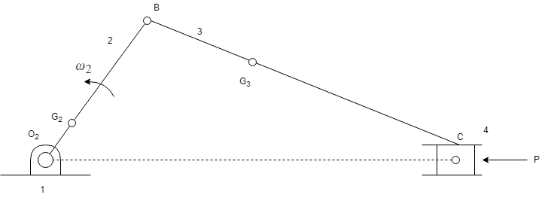

1. Configuration diagram

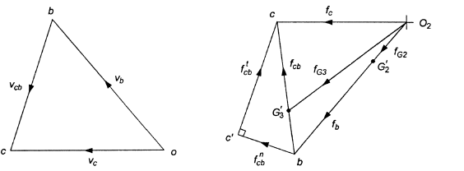

(b) velocity diagram (c) acceleration diagram

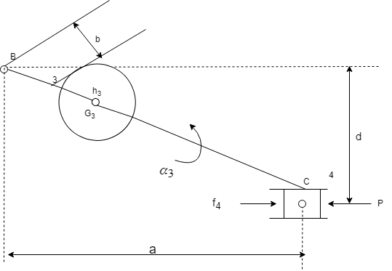

(d)

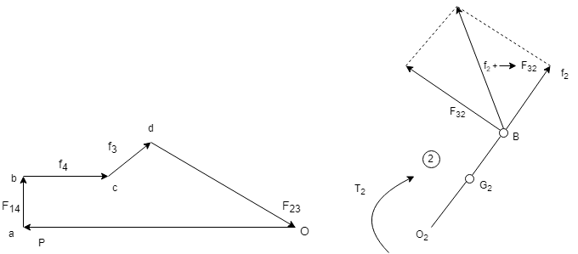

(e) (f)

**Fig. 1** Static and inertia force analysis of slider-crank mechanism

The free body diagram for link 2 is shown in [Fig.1](https://learning.oreilly.com/library/view/Theory+of+Machines/9789332528567/xhtml/chapter011.xhtml#ch11fig22), where

F12 = −(f2 parrow F32)

The torque exerted by the shaft on the crank 2 at O2 is,

T2 = −(f2 parrow F32) e

The torque exerted by the crank on the crankshaft is equal to T2 but opposite in sense to T.

SOURCE:[2] <https://www.academia.edu/37828056/Chapter_-2_DYNAMIC_FORCE_ANALYSIS>

**3. Flowchart:**

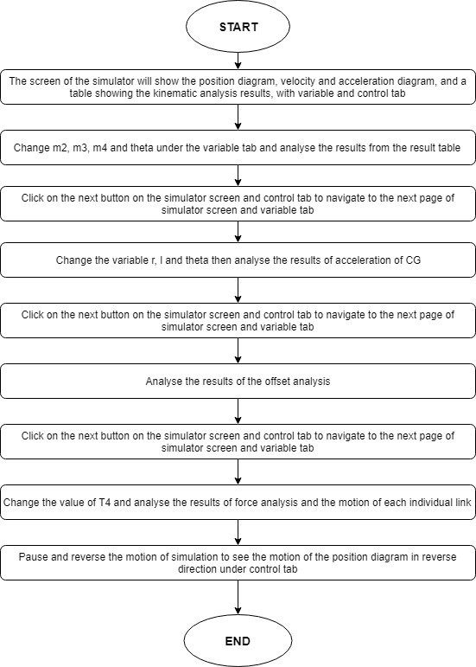

1. **Mind map:**

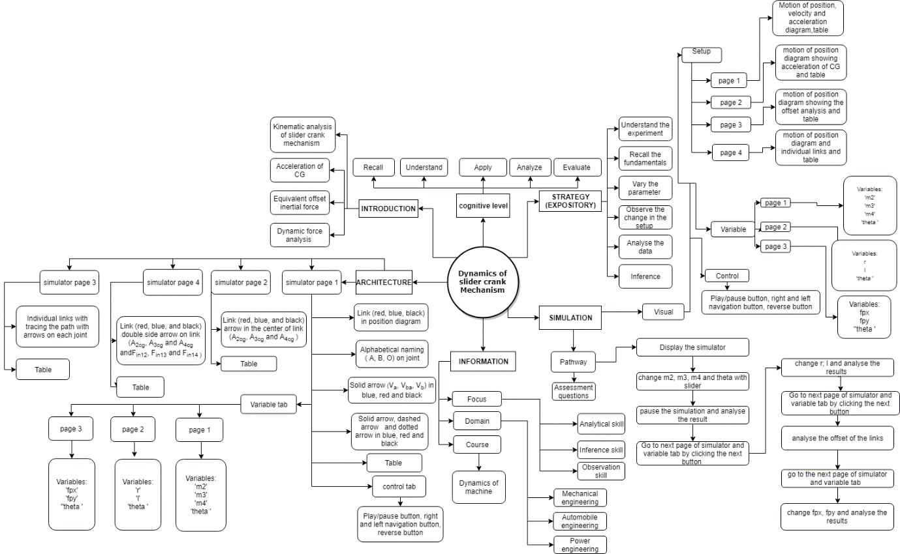

1. **Storyboard:**
   1. In simulation window the motion of position diagram, velocity and acceleration diagram is shown.
   2. There are pointers given on right side of the screen under the variable tab to change the values of m2, m3 m4 and 2, and navigation, play/pause and reverse button under control tab. Navigation buttons given on the simulator screen for the navigation of the simulator screen.

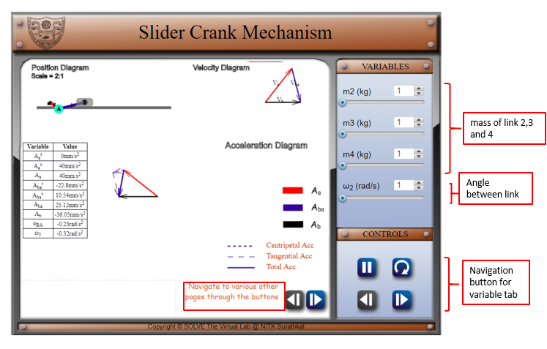

* 1. After moving on to the next page of simulator screen and variable tab, change value of r, l, and theta of the link.

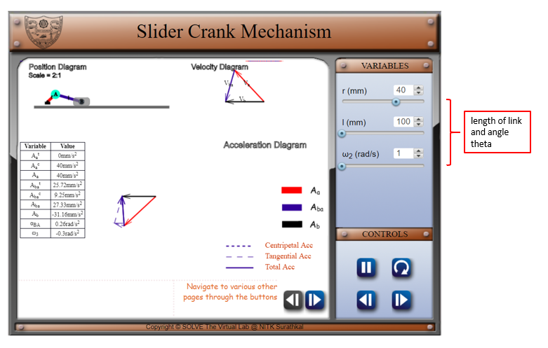

1. Navigate to the next page of the simulator screen. And analyse the offset analysis results from the table after pausing the animation,

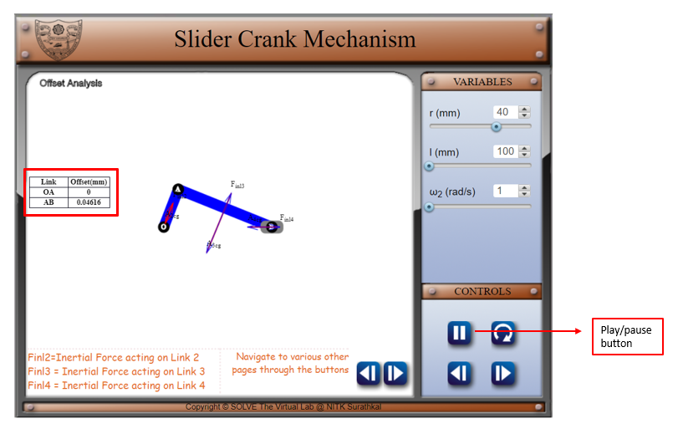

1. Navigate to the next page of simulator screen and variable tab and change fpx, fpy and reverse the animation using the control tab, then analyse the force on links.

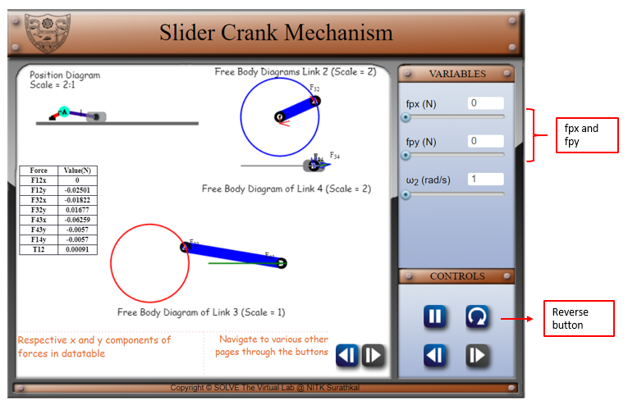

REFERENCE:

[1] Theory-of-Machines-14th-ed-Khurmi-2005 (2)

[2] <https://www.academia.edu/37828056/Chapter_-2_DYNAMIC_FORCE_ANALYSIS>